Supplementary material 4

# Dynamic Inflow and Evaporation (DIE) box model.

The DIE box model is an excel-based tool designed to solve numerically in 1000 time-steps of predefined duration (Δt) the mass balance of water and salt (dissolved and precipitated) in a basin that has a ellipsoidal cap geometry. An ellipsoidal cap geometry was chosen to ensure that the surface-area to volume ratio of the basin is changing (increasing) with depth, which is consistent with the geometry of basins. The total accommodation remains constant during the evolution of the basin since there is no tectonic, thermal or flexural subsidence during the modeled history. This geometry also ensures that at any given combination of fresh water flux and evaporation rate, there will be an “equilibrium” lake level.

Forward modeling balances the mass of water/brine and precipitated salt volume in each timestep of the simulation. The volume of brine and salt are converted to thicknesses/depth at the center of the basin using the ellipsoidal cap geometry and the loads are balanced isostatically with a column of air (if necessary) during the evolution of the basin.

The inputs of the model include the basin geometry (Length, Width, Water Depth (WD)), the inflow of seawater (Q_swm) and River water (Q_rm), the rate of evaporation and the Salinities of seawater (C_sw) and River water (C_rw).

A complete screenshot of the input table is shown below:





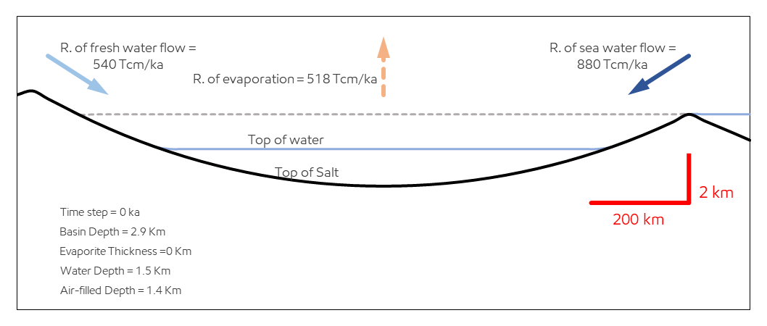

Basin Volume and surface area are calculated from the following equations:

Where:

c = 2.1xWD, (WD is the initial maximum water filled accommodation in the basin; an input)

h is the base level of water/brine in the center of the basin,

a = L/(sqrt(0.73)), (L is the length of the basin; an input)

b = W/(sqrt(0.73)), (W is the width of the basin; an input)

The River water discharge, seawater discharge and rate of evaporation are inputs in trillion cubic meters per 1000 years (Tcm/ka). Salinity of both river water and seawater are customizable. The seawater, river water discharge and evaporation rates can be scaled to simulate Milankovitch cyclicity of inflow of water during the simulation period. The period of the cyclicity is controlled by the user (e.g., 23 k.a. precession cycles), calculated using simple Sine curves. The amplitude of the variability of the inflow rate is calculated using sine curves and scaled to the ratio of eustatic base level change and the opening of the sill/inlet that allows seawater inflow to the basin. If the eustatic base level change is larger than the opening of the sill, then during the lowering of the base level, the inflow into the basin is reduced to zero:

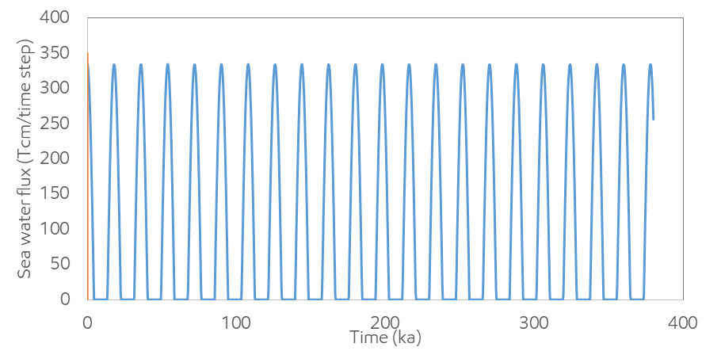 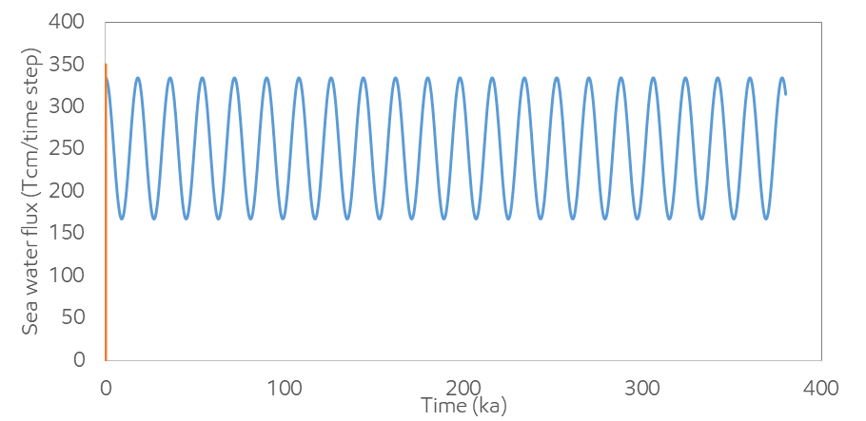

Left: Eustatic base level change of 100m, 50 m sill height.

Right: Eustatic base level change of 100m, 200 m sill height.

In addition to Milankovitch cyclicity, the DIE box mode allows the user to linearly increase or decrease the inflow rate of seawater in order to simulate the tectonic opening (widening) or closing (shortening) of the width of the sill during the simulation period. The processes (Milankovitch cyclicity and tectonic inlet widening) can be combined:

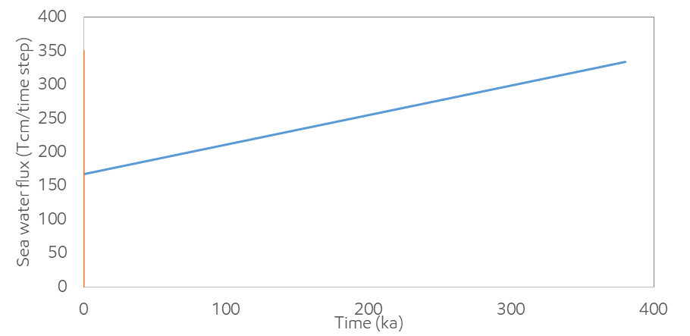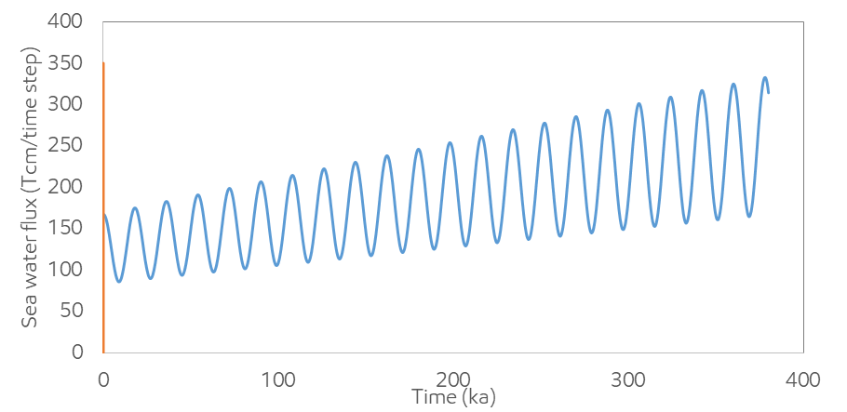

Left: Linear seawater inflow increasing due to sill widening

Right: Combined effect of linear seawater inflow increase due to sill widening and eustatic base level change of 100m, with a 200 m sill height.

The input parameters are used to estimate the total accommodation of the basin and the proportion that is filled with brine, air and salt at any given Δt (see detailed flow chart for workflow of box model). The box model estimates the amount of river flux, seawater flux and evaporation at each Δt, ensuring that any brine volume that exceeds the available accommodation is not allowed to enter the basin. If the total inflow of water exceed the available volume of the basin and the amount of evaporation in any Δt, then the brine is “circulated” out of the basin and into the global ocean. In this case the efficiency of brine circulation can be adjusted between a minimum and maximum value. The efficiency coefficient is simply the ratio of brine salinity relative to seawater salinity that is removed from the box model. The circulation efficiency coefficient is inversely linearly scaled to brine salinities (and density) in the basin (low salinity has high circulation efficiency and vice versa).

The mass of total salt in the basin is estimated from the flux of seawater and the existing amount of salt in the basin (from the n-1 Δt). The maximum salinity of the brine is used to estimate the evaporative phases in equilibrium with brine at each Δt and this is in turn used to estimate the “excess” salt that will precipitate out of solution using the following relationships:

Solids:water = Total solids in the basin/water mass (g/kg)

If Solids:water is <150, then no precipitation (below gypsum saturation)

If Solids:water is >150 and <280, then A_pp is 0.06 (below halite, above gypsum saturation)

If Solids:water is >6000, then A_pp is 0.95

If max salinity is >280 and <6000 (above halite saturation), then the following beta function was used:

A_pp = 0.7+ (0.25*(BETA.DIST(Solids:water,0.45,4.4,cumulative,279,6000)))

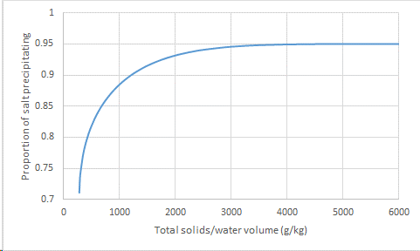

The mass/volume of salt precipitated and brine at each time step were converted to salt and brine thickness at the deepest location of the basin using the ellipsoidal cap equation above. Then the total depth at the center of the basin was adjusted for isostacy and the remaining accommodation (if any) is replaced by air using the following equation

Where:

A = “thickness” of air-filled component at the center of the basin

Br = “thickness” of brine at the center of the basin

S_t = thickness of salt at the center of the basin

WD = initial water-filled accommodation of the basin

ρ_br = density of brine (=1000-1450 kg/m3) depending on brine salinity

ρ_m = density of mantle (=3300 kg/m3)

ρ_s = density of salt (=2100-2300 kg/m3) depending on salt composition

ρ_w = density of seawater (=1025 kg/m3)

The equation above implies that when the basin water is completely evaporated and no salt is deposited, A = WD*(0.689); i.e., one kilometer of seawater is replaced by **689** m of air. Also, if all the water of the basin is replaced with salt, A = 0, S_t = WD*(2.07), for salt density of 2200 kg/m3; i.e., one kilometer of seawater is replaced by **2070** m of salt.

The minor axis of the ellipsoid (“c”) is recalculated at each Δt by adding the thickness of salt, brine and air of that timestep.

In addition to volumetric and mass estimates of brine, salt and air at each time step, the Sr and O isotope compositions of the brine were also calculated with the same box model. Below is a screen capture of the inputs for isotopic modeling:



The oxygen isotope evolution of the modelled brine basin was calculated at each time step using the Rayleigh equation in Cappa et al., (2003) and the aeffvalues reported for 50% humidity in their paper. Oxygen isotope compositions of river water and seawater are inputs to this model. The extend of evaporation at each time step (f) was estimated using the modeled total inflow of river and sea water, the volume of the brine from the previous time step and the evaporation volume

f = evaporated volume/(total inflow of river water + lake volume at previous timestep).

The Sr concentration and isotope evolution of the modelled brine was calculated by volumetric and concentration mixing of the three water sources at each time step (River water, Sea water and the brine composition at the previous time step). The Sr concentration of the brine at each time step was calculated by adjusting for the water evaporative loss by tracking the mass of Sr at each time step. If the concentration of the lake ever reached >150 g/kg, 6% of the excess (>150 g/kg) salinity was “precipitated” as anhydrite and Sr was fractionated into the anhydrite using a batch fractionation model with a Sr partition coefficient (D) of 0.2-0.4 (D values as defined in Kushnir, 1982). Sr isotope evolution of the brine was also calculated by the concentration-weighted average mix of the three components mentioned above (River water, Sea water and the brine composition at the previous time step). No mass-depended fractionation of the Sr isotopes is modelled for the Sr fractionated in the anhydrite (if precipitated).