Supplementary Materials and Methods
- Materials
Nineteen cored wells located at areas that close to the main strike-slip faults (F1, F3, F5, F8, and F11) were selected to study the history of fault activities and provide constrains for cavern reservoir formation and petroleum accumulation history. We have investigated approximate 240 m cored sections mainly obtained from the Middle Ordovician intervals, some of which are very close to the production zone characterized by considerable lost circulation and/or bit drops (Fig. S1). Ten among 19 cored wells contain calcite fillings. 15 samples, 14 calcites and 1 barite, occurring as fillings in vugs, fractures, and caverns, were collected and sample details are summarized in Table S1. Petrological and geochemical analyses including Cathodoluminescene (CL), C, O, and Sr isotopes, trace elements and REEs, and clumped isotopes and U-Pb dating analyses were performed in order to determine the diagenesis sequence and timing these calcites and related reservoirs formation. Petrological features of typical samples were presented in Figs. S2, 3, and 4. Each sample was prepared three mirror thin-sections, two were used for optical and CL observations and U-Pb dating while one for micro scale sampling for geochemistry analyses, including carbon, oxygen, and strontium isotopes, trace elements and REE, and clumped isotope measurements.
Figure S1. Well correlation showing the locations of cored section and the lost circulation and bit drops. In the lower part, the grey color boxes represent the vertically exaggerated cored sections with core recovery length and footage cored, yellow stars showing the sample positions.
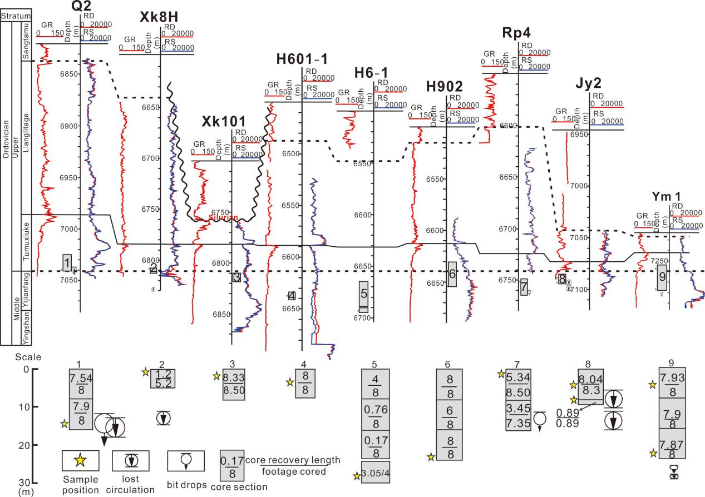

- Table S1
Summary of samples information and occurrence of calcites
No. | Well | Stratum | Calcite type |  | crystal | Cathodoluminescene | Remarks
H10 | H902 | O2y | Calcite in vuggy pores (VC) |  | Enhedural, Crystal size > 1mm | Non-luminescent with bright orange rim | Below the top of Middle Ordovician, host rock oil-stained
H11 | H902 | O2y |  |  |  |  | Below the top of Middle Ordovician, patchy oil-stained in vugs
H12 | Hd27 | O2y |  |  |  |  | oil-stained
H13 | H601-1 | O2y | Calcite in interbedded fractures (IFC) |  | Enhedural with crystal size >2 mm, cut by tiny calcite filled fracture | Non-to dull luminescent, tiny calcite shows orange luminescent | Fracture is completely filled with calcite, no oil stained
H16-1 | Jy2 | O2y |  |  |  |  | Fracture is completely filled with calcite, no oil stained
H6 | Xk101 | O2y | Calcite in high-angle dissolved fractures (DFC) |  |  |  | Fracture length up to 7 m, no related bit drops or loss of circulation
H19 | Ym1 | O2y | Calcite in high-angle structural fractures (SFC) | SFC-1 | Enhedural with crystal size >1mm, cleavage crack parallel to the wall | Non-luminescent | Partially filled with calcite, oil stained. 80° inclination, scoring on the wall. Bit drops and loss of circulation occurred 5 m below the sample
H20 | Ym1 | O3t |  |  |  | Dull to dark red luminescent | Same as H19, oil stained. About 20 m from the section where there is loss of circulation
H17 | Jy2 | O2y |  | SFC-2 | Syntaxial, up to 2 mm | Dull to bright orange luminescent | Partially filled with calcite, 0.5 cm in width, and has an inclination of 70°. Bit drops and loss of circulation occurred 2 m below the sample
H16-2 | Jy2 | O2y |  |  |  | dark red to bright orange zoned | Vertical fractures filled with a little calcite, also called as calcite bridge, 0.1 cm in width, cut the entire fabric
H14 | Q2 | O3t |  | SFC-3 |  | orange to bright orange luminescent | Completely filled with calcite, 1 cm in width, bit drops and loss of circulation occurred below the sample
H1 | Qg1 | O2y | Megacrystalline calcite (MC) |  | Generation 1 (H1-1): blocky (>5 cm); Generation 2 (H1-2): zoned (~ 1 mm) | Generation 1 (H1-1): Massive homogeneous orange；  Generation 2 (H1-2): dull to bright orange zoned; | 0.5 m thick in cores, core recovery is 60%
H3 | Qg1 | O2y |  |  | Blocky, >10 cm | dull to bright orange zoned | Fractures are larger than 1.5 cm in width and almost vertical, extending downward up to 10 m to connect with Sample H1
H7 | H6-1 | O2y |  |  | Two generations, blocky, >10 cm | Generation 1 (H7-1): Non to dull luminescent  Generation 2 (H7-2): bright orange luminescent | 0.3 m thick in core, curve boundary with the host rock
H9 | Xk8H | O2y |  |  | Blocky, >10 cm | Bright orange | 0.5 m thick in core, core recovery is 23.1%, bit drops occurred 20 m below the sample
H8 | Rp4 | O2y | Barite |  | Blocky, >10 cm | Non-luminescent | Accompanying megacrystalline calcite, 1 m thick in core. Loss of circulation occurred 10 m below the sample

- Figure 2
Core, thin-section, and CL microphotographs of vug-filling calcites. (a) core photo image showing vugs filled with calcite, appearing as dark patches within irregular geometries (single channels or amalgamations of channels), black color indicates oil-stained; (b) thin-section image showing vug filled with calcite (C), host rock (H) has packstone fabric; (c) CL image of (b) showing that calcite (C) in vug has dull luminescent with bright rims, note that the yellow line showing the sampling position of U-Pb dating.

- Figure 3
SFC-1 calcite partially filled in structure fracture which are observed in core (a) and thin-section (b), showing dull to bright luminescent (c). SFC-2 calcites filling with structure fracture observed in core (d) and thin-section (e), are non-luminescent (f) and oil stained. SFC-3 calcite are observed in core (g) and thin-section (h) as well, which showing dull to brown luminescent CL color (i). Yellow lines in c, f, and i show the position of U-Pb dating experiment.
- Figure 4.
Megacrystalline calcites (MC) which observed in core (a) and thin-section (b) showing two generation with dull to orange zoned luminescent and orange luminescent (c) at well H1; MC calcites which observed in core (d) and thin-section (e) either showing dull luminescent or orange luminescent under CL (f) at well H7-2; (g-i) MC calcites which observed in core (g) and thin-section (h) displaying homogeneously bright orange luminescent (i); Barite intergrowth with MC calcite were locally observed in core (j) and thin-section (k), which is non-luminescent under CL. Note that the yellow lines shows the positions for U-Pb dating experiment.

- Stable carbon and oxygen isotopes methodology
For stable carbon and oxygen isotopes, ~10 mg of powder was reacted with 100% phosphoric acid for 4 h at 50 ℃. The produced CO₂ was measured for oxygen and carbon isotopic ratios in a DELTA V Advantage mass spectrometer. Isotopic values are presented using δ-notation and are reported relative to the Vienna Peedee Belemnite (VPDB) standard. The accuracies of the δ¹³C and δ¹⁸O values are ±0.1‰ and ±0.2‰, respectively.
- Strontium isotopes methodology
For strontium isotope analysis, 100-150 mg of powdered sample was dissolved using a mixture of anhydrous 1 mL of HNO₃ and 1 mL of HF in a crucible at 190 ℃ for 48 h. Strontium was extracted using conventional exchange procedures (Baadsgard, 1987). ⁸⁷Sr/⁸⁶Sr ratios were measured using a Triton Plus thermal ionization mass spectrometer and corrected relative to the NBS987 standard. The analytical mean error (2 sigma) is ±0.5 × 10⁻⁵ for ⁸⁷Sr/⁸⁶Sr ratios.
- Trace elements and REE methodology
Trace elements and REE were tested by HR-ICP-MS (ELEMENT XR). 50-100 mg of powder from each calcite sample was dissolved in a mixture of 0.6 mL of nitric acid and 2.5 mL of hydrofluoric acid solution at 185 ℃ for 72 h. After drying, it was reacted with 4 mL of 20% mixed acid (HCl: HNO₃ = 4:1) at 130 ℃ for 3 h. After the acid had been excluded, the resulting solution was analyzed with a Thermo X-series ICP-MS in high-performance mode with standard instrument conditions. Instrument response was calibrated against two independent digests of USGS reference material W-2 and confirmed by analysis of other reference materials. Corrections were applied for oxides using formation rates determined from pure single-element REE standards.
- LA-ICP-MS U-Pb geochronology
Ten samples (3 VCs, 3 SFCs, and 4 MCs) were chosen to perform the laser-ablated U-Pb dating. Samples were prepared as 100 µm thick thin sections and polished. After optical and cathodoluminescent observation, dating fabrics were determined for each sample and were ablated and analyzed using a Geolas HD laser ablation system with a 193 nm beam coupled to an Element XR Induced Coupled Plasma Mass Spectrometer (ICP-MS) housed at the China National Petroleum Corporation (CNPC) Key Laboratory of Carbonate Reservoir. The laser beam diameter for calcite sample and calcite reference material was 160 µm, at 6 Hz, and with a fluence of 2 J/cm2 (Table S2). Two calcite samples of known age, NIST 614 and WC-1 (Roberts et al., 2017), were used as calcite reference materials. NIST 614 was used for the ²⁰⁷Pb/²⁰⁶Pb calibration and WC-1 with the age of 254.4 Ma was used for ²³⁸U/²⁰⁶Pb calibration by a linear correction. Additionally, the Laboratory calcite reference material AHX-1 (Shen et al., 2019) with the age of 209.8±2.0 Ma (MSWD=3.0) was used to check the result quality (detailed data for AHX-1 seen in the supplementary material).
Ablation were performed in a helium atmosphere (0.6 l/min) and mixed in the ablation funnel with 0.9 l/min argon and 0.005 l/min nitrogen. Signal strength at the ICP-MS was tuned for maximum sensitivity while keeping oxide formation below 0.3% (UO/U) and element fraction low (e.g., Th/U = 1). During the experiment, after the thin-section was loaded into the tray, following a 20 s period of baseline accumulation, the laser was turned on and pre-ablated the spots for 2 seconds to clean the surface. Then the data were collected for 40 s and followed by a 30 s washout period, totally it takes about 1.5 min for each one spot. Seven unknowns were analyzed between each two-reference material analysis. About 40 spots (32~71) were ablated for each sample as suggested by Roberts et al. (2017). Data reduction and uncertainty propagation follow Roberts et al. (2017) and the recommendations of Horstwood et al. (2016), and the original uncertainty of either WC-1 or AHX-1 date was not propagated through to the analyses, considering most of the uncertainties are too small to change the results significantly. Age calculations and plotting were performed using Isoplot 4.15 (Ludwig, 2012). The conventional Tera-Wasserburg (T-W) plot of ²⁰⁷Pb/²⁰⁶Pb v. ²³⁸U/²⁰⁶Pb was used to determine regression ages.
- Table S1
LA-ICP-MS operating conditions
Laboratory & Sample Preparation
Laboratory name | Hangzhou Research Institution of Geology, CNPC
Sample type/mineral | Carbonate
Sample preparation | Fragments of rock with veins, 1'' epoxy mount or 50μm Thick sections
Imaging | Reflected light image
Laser ablation system
Make, Model & type | Coherent GeoLas HD ArF
Ablation cell & volume | normal circle cell
Laser wavelength (nm) | 193nm
Pulse width (ns) | 3 ns
Fluence (J.cm‐2) | 3 J/cm2
Repetition rate (Hz) | 6 Hz
Spot size (um) | 160μm
Sampling mode / pattern | Static Spot
Ablation duration (secs) | 40 secs, 20 s washout, 20 s background between pulses
Cell carrier gas flow (l/min) | He (630ml/min), N2 (6ml/min)
ICP‐MS Instrument
Make, Model & type | ThermoFisher Element XR
Carrier gas flow rate | 0.9 L/min Ar
Auxilary gas flow rate | 0.8 L/min Ar
RF power (W) | 1200 W
Detection system | Ion counter
Masses measured | 206Pb, 207Pb, 208Pb, 232Th, 238U
Integration time per peak (ms) | 10-15ms
Data Processing
Gas blank | 20 second on‐peak zero subtracted
Calibration strategy | NIST614 for Pb-Pb, WC-1 for Pb-U
Reference Material info | SRM614 glass and 254.4 ± 6.4 Ma WC‐1 for final Pb/U calibration, 209.8±1.3Ma AHX-1 calcite for quality control
Data processing package used / Correction for LIEF | Iolite© 3.65software, using the 'Linear spline' to correct for downhole fractionation and the 'Automatic spline' to correct for instrumental drift
Common‐Pb correction, composition and uncertainty | Unanchored (model 1) regressions in Tera-Wasserburg (Semi Total-Pb) plots
Uncertainty level & propagation | Ages in the data table are quoted at 2s absolute and include systematic uncertainties, uncertainties of standard were not propagated to the analysis

- Clumped isotopes
Clumped isotopes were measured firstly in the laboratory at the Department of Earth and Space Sciences, University of California, Los Angeles, and then in CNPC Key Laboratory of Carbonate Reservoir, Hangzhou, following the procedure described by Loyd et al. (2013). About 10 mg sample powers were digested in phosphoric acid (density=1.92 g/ml) at 90 °C for 20 min. The produced CO₂ was successively passed through a metal trap immersed in liquid N₂ and a glass water trap immersed in a dewar of ethanol at 70 °C. After two rounds of cryogenic purification to remove water, CO₂ was then passed through a gas chromatograph column filled with PoraPak Q at 20 °C, and a silver foil trap. Then, the purified CO₂ was transferred to a Thermo Fisher 253 gas-source mass spectrometer to collect masses 44-49. Δ47 data are corrected for acid reaction temperature to normalize values to a 25 °C reaction temperature by applying an acid digestion correction of 0.08‰ to convert from 90 to 25 °C (Passey et al., 2010). The new Δ47 data are reported on the absolute reference frame (ARF, also called CDES for Carbon Dioxide Equilibrated Scale; Dennis et al., 2011). Δ47 data are converted to temperatures using the calibration established in Ghosh et al. (2006) modified for application to the absolute reference frame (Dennis et al., 2011). Coupling the Δ47 temperatures and the paired δ¹⁸O_{carb} values, oxygen isotopic compositions of parent fluids (δ¹⁸O_{SMOW}) were calculated by the empirically derived relationship of Kim and O’Neil (1997).
A Carrara Marble was used as the standard for clumped isotope measurements in the Tripati laboratory, which yields a Δ47 value of 0.397. The average reproducibility of this Carrara Marble standard is better than 0.1‰ (1σ) for δ¹⁸O and δ¹³C before standardization and better than 0.01‰ after standardization

12. References
Baadsgard H., 1987. Rb Sr and K Ca isotope systematics in minerals from potassium horizons in the prairie evaporite formation, Saskatchewan, Canada: Chemical Geology Isotope Geoence, v. 66, p.1-15, doi:10.1016/0168-9622(87)90022-4.
Dennis, K. J., H. P. Affek, B. H. Passey, D. P. Schrag, and J. M. Eiler, 2011. Defining an absolute reference frame for ‘clumped’ isotope studies of CO₂: Geochimica et Cosmochimica Acta, v. 75, p. 7117-7131, doi:10.1016/j.gca.2011.09.025.
Horstwood, M. S. A., J. Košler, G. Gehrels, S. E. Jackson, N. M. McLean, C. Paton, N. J. Pearson, K. Sircombe, P. Sylvester, P. Vermeesch, J. F. Bowring, D. J. Condon, and B. Schoene, 2016. Community-derived standards for LA-ICP-MS U-(Th-)Pb geochronology—uncertainty propagation, age interpretation and data reporting: Geostand Geoanal Res., v. 40, no. 3, p. 311-332, doi:10.1111/j.1751-908X.2016.00379.x.
Kim, S.T., and J.R. O'Neil, 1997. Equilibrium and nonequilibrium oxygen isotope effects in synthetic carbonates: Geochimica et Cosmochimica Acta, v. 61, p. 3461-3475. doi: 10.1016/ S0016-7037(97)00169-5
Loyd, S. J., J. A. D. Dickson, P. A. Scholle, and A. K. Tripati, 2013. Extensive, uplift-related and non-fault-controlled spar precipitation in the Permian Capitan Formation: Sedimentary Geology, v. 298, p. 17-27, doi:10.1016/j.sedgeo.2013.10.001.
Ludwig, K. R., 2012. User’s manual for isoplot 3.75-4.15, Berkeley Geochronology Center.
Passey, B. H., N. E. Levin, T. E. Cerling, F. H. Brown, and J. M. Eiler, 2010. High temperature-environments of human evolution in East Africa based on bond ordering in paleosol carbonates: Proceedings of the National Academy of Sciences, v. 107, p. 11245-11249, doi:10.1073/pnas.1001824107.
Roberts, N. M. W., E. T. Rasbury, R. R. Parrish, C. J. Smith, M. S. A. Horstwood, and D. J. Condon, 2017. WC-1: A calcite reference material for LA-ICP-MS U-Pb geochronology: Geochemistry, Geophysics, Geosystems, v. 18, p. 2807-2814, doi:10.1002/ 2016GC006784.
Shen, A. j., A. P. Hu, T. Cheng, F. Liang, W. Q. Pan, Y. X. Feng, and J. X. Zhao, 2019. Laser ablation in situ U-Pb dating and its application to diagenesis-porosity evolution of carbonate reservoirs: Petroleum Exploration and Development, v. 46, p. 1062-1074, doi:10.1016/S1876-3804(19)60268-5.

